Explanatory Note of the Coordinated Redispatching and Countertrading methodology for SEE CCR

Version | 1.0
Date | 17-03-2018
Status | Final | Draft

Contents

1. Introduction 3
2. Definitions and acronyms 3
3. Cross- Border Relevance and Area of Common Interest (ACI) 6
4. Resources for RDCT 7
5. Overall process and RDCT resources calculation and commitment 8
5.1. Regular process 8
5.2. Fast activation process for sudden critical situations 10
6. Timeframes for RDCT application 10
7. Involved parties and roles 11
7.1. Coordinated security monitoring of the ACI for RDCT application 12
7.2. RDCT measures calculation and selection 12
8. Dataset and tools 12
8.1. Grid models 12
8.2. Dataset for ACI definition 13
8.3. Non-costly remedial actions 13
8.4. Common platform 13
8.5. Common tool 13
9. Connection between RDCT and Capacity Calculation processes 13
10. Transparency 14
11. Implementation roadmap 14
Annex 1 Redispatching and Countertrading measures summary table 15

Introduction
This document provides a technical description of the methodology for coordinated redispatching and countertrading affecting the borders of the capacity calculation region (CCR) SEE CCR and complement the document with the methodology proposal submitted to stakeholders for consultation and to the national regulators of the region for approval. The participating TSOs to the coordinated redispatching and countertrading are ADMIE (Greece), ESO (Bulgaria), and Transelectrica (Romania).
The proposed methodology follows the Article 35 of the COMMISSION REGULATION (EU) 2015/1222 of 24 July 2015 establishing a guideline on Capacity Allocation and Congestion Management (CACM) and:
- Provides the principles for a common methodology for coordinated redispatching and countertrading which will be consulted with stakeholders of the involved Parties;
- Paves the way to a future pragmatic implementation of the redispatch and countertrading processes, which will follow after the approval by the relevant Authorities of the present methodology.

Definitions and acronyms
This chapter deals with detailed definitions and interpretations to be used in the scope of the countertrading and redispatching common methodology, and the timeframes in which its different processes apply (with different purposes, such as guarantee firmness of capacity, emergency delivery, etc.). Before developing a glossary, a unique definition of the following acronyms is necessary:
ACI: Area of Common Interest
CC: Capacity Calculation
CGM: Common Grid Model
CRA: Curative Remedial Action
CRAC: Contingencies, Remedial actions, Additional Constraints
CNE: Critical Network Element
CT: Counter Trading
D2CC: D-2 Capacity Calculation
DACF: Day Ahead Congestion Forecast
GSK: Generation Shift Key
IDCC: Intra Day Capacity Calculation
IDCF: Intra Day Congestion Forecast
PRA: Preventive Remedial Action
RA: Remedial Action
RD: ReDispatching
RDCT: ReDispatching Counter Trading
RSC: Regional Security Coordinator
SCOPF: Security-Constrained Optimal Power Flow
SN: Snapshot
SO GL: System Operations Guide Line on Electricity Transmission System Operations
TSO: Transmission System Operator
On the base of these definitions, the Parties developed a shared glossary aimed at reaching a common understanding on the matter. For the avoidance of doubt, following definitions and interpretations do not replace any provision of national or European law that may apply to any of the Parties. They shall comply with and be complementary to the applicable regulations. In case of contradictions between these definitions and interpretations and the applicable law its provisions shall be interpreted in line with the applicable regulations or amended accordingly.

Area of Common Interest (ACI) | A detailed definition is given in chapter 3.
Aggregated Netted External (ANE) Schedule | Means a Schedule representing the netted aggregation of all External TSO Schedules and External Commercial Trade Schedules between two Scheduling Areas or between a Scheduling Area and a group of other Scheduling Areas.
Cross-border relevant Remedial Action | A detailed definition is given in chapter 3.
Economically efficient multilateral remedial actions | Means actions which are taken among different TSOs (at least three) with a goal to relieve the critical situation while minimizing the activation costs (in the moment of activation) and taking into account the influence of measure on the critical network element(s).
Internal relevant Remedial Action | Means a remedial action which is performed with the goal to relieve a constraint(s) without XB-Relevance.
Internal Commercial Trade (ICT) Schedule | Means a Schedule representing the commercial exchange of electricity within a Scheduling Area between different Market Participants or between Nominated Electricity Market Operators and Market Coupling Operators.
Multilateral remedial actions | Means actions which are taken among different TSOs (at least three) and used to solve xb-relevant security violations.
Redispatching/Countertrading  Measures | Defines all the different type of measures, modifying the injection of one or more power plants, taken to ensure system security and firmness of Capacity and Exchange Programs on and around the border of countries.  All the Redispatching Measures can be applied bilaterally or among several TSOs.
 | Countertrading | This Redispatch Measure is a TSO-initiated transaction between two control areas in order to relieve a congestion between these two areas. The location in the two control areas where the increase or decrease of energy takes place is arbitrary, in the sense that it is not a specific action on a predefined generation unit, but rather a choice based on the merit order or any other location-independent method if such exists. This measure implies the modification of schedule.
 |  | Internal  Redispatching | This Redispatch Measure is implemented when a TSO decides to do Redispatching in its own control area.
 |  | External  Redispatching | This Redispatch Measure is implemented when TSO A requests TSO B to do Redispatching in control area B in order to relieve constraints in control area A.
 | Cross Border  Redispatching | This Redispatch Measure is about increasing (decreasing) the level of production of a designated generation unit in TSO A and decreasing (increasing), by the same volume, the level of production of another designated generation unit in TSO B. To that end, TSO A increases or decreases the production by activating upward or downward offers based on both the location and costs of the generation units and TSO B counteracts in his control area. In detail, generating units are mainly selected based on their sensitivity on the constrained element (and not only according to the economical merit order). Moreover at the same time, the TSO will have to initiate a transaction between the two control areas, corresponding to the amount of generation Redispatching done in each control area. This measure implies the modification of schedule between TSOs.
Schedule | Means a reference set of values representing the Generation, consumption or exchange of electricity between actors for a given time period.
Remedial action (RA)  (according to UCTE Operational Handbook Policy 3) | RA refers to any measure applied in due time by a TSO in order to fulfill the operational security of the transmission power system regarding power flows and voltage constraints.
 | Preventive Remedial Actions (PRAs) | PRAs are those launched to anticipate a need that may occur, due to the lack of certainty to cope efficiently and in due time with the resulting constraints once they have occurred.
 | Curative Remedial Actions (CRAs) | CRAs are those needed to cope with and to relieve rapidly constraints with an implementation delay of time for full effectiveness compatible with the Temporary Admissible Transmission Loading. They are implemented after the occurrence of the contingencies.

Cross- Border Relevance and Area of Common Interest (ACI)
A cross-border relevant network element is a CNE (Critical Network Element) as defined in the Capacity Calculation Methodology.
A cross-border relevant remedial action is a remedial action that relieves a congestion on cross-border relevant network elements.
The Area of Common Interest (ACI) is the set of grid elements with a cross-border relevance (used for capacity calculation) and whose potential physical congestions can be effectively relieved by cross border Redispatching and Countertrading measures.
In order to improve efficient and fair application of Redispatching and Countertrading and to keep operations as smooth, reliable and secure as possible, it is essential to have simple and clear procedure to identify and agree upon the elements of the transmission grid belonging to the ACI.
The definition of the ACI has to respect the following principles:
- Effectiveness: the grid elements must have a cross-border relevance (used for capacity calculation) and their potential physical congestions must be effectively relieved by the Redispatching and Countertrading measures.
- Flexibility: the ACI shall be continuously adapted in line with the most updated information about the grid (e.g. unplanned outages, topological modifications, etc.).
The definition of the ACI is a key point of this methodology since only congestions occurring on its elements will be taken into account for RDCT applications.
In order to respect the above mentioned principles and to be coherent with the operational experience, the ACI will come through the following two assessments:
- Every TSO defines a list of its own grid elements which are supposed to have a cross-border relevance and whose potential physical congestions can be effectively relieved by cross border Redispatching and Countertrading measures available in the SEE CCR.
- The filtering is based on sensitivity analysis: the elements whose sensitivities to the application of RDCT measures are above a threshold are included inthe ACI..

The ACI shall be reviewed periodically and the frequency of its updating shall depend on what will be agreed and considered technically feasible by the TSOs during the implementation phases. The sensitivity analysis at point 2 will be performed using the same dataset used for assessing the RDCT volumes. This means that the cross-border exchanges will be realized by shifting the same resources (e.g. nodal generation/load adjustment, proportional generation/load up/downward in a wide area, etc.) declared available for RDCT (see paragraph 4).

Resources for RDCT
Even if they are implemented in different ways, both Redispatching and Countertrading aim at removing violations on grid elements of the ACI by shifting generation/load in one part of the grid and rebalancing the same amount in another part.
It is crucial to have suitable in advance a clear and reliable overview of the available resources and their actual or estimated prices in order to:
- Properly define the ACI and perform the filtering process (see paragraph 0).
- Calculate the amount of generation/load involved in RDCT.
- Identify the generation/load to be shifted (i.e. this is valid for Redispatching).
- Minimize the actual or estimated costs of RDCT for the SEE CCR region.
Each TSO shall declare, for each time frame, the resources available in its control area for RDCT and their prices. The prices shall reflect the actual prices of the resources, when the information is available, or the best estimation of the costs incurred by the TSOs in accordance with the appropriate mechanisms and agreements applicable to their control areas. The resources will be defined for two different services:
- increasing the control area balance (e.g. increasing generation/decreasing load);
- decreasing the control area balance (e.g. decreasing generation/increasing load).

In case of Redispatching each TSO has to declare the location of the resources, the available upward/downward redispatching capacity, the prices of the potential generation or load units, the full activation time, and the time window of its validity.
In case of Countertrading each TSO has to specify the available countertrading capacities and their prices. The declared prices must be estimations of the market costs expected by the TSO (e.g. average cost for increasing area control balance by x MWh).
In accordance with the appropriate mechanisms and agreements applicable to the control areas, information about prices may be made available in advance by generation units and loads, thus allowing TSOs to estimate redispatching and countertrading prices.
TSOs shall provide the best estimations of expected costs and, for sake of transparency, to share the methodology they implement in order to define in advance the prices of their CT resources.
RDCT resources will be declared using a Generation Shift Keys (GSK) file format in a similar way as it is done for capacity calculation processes (e.g. D2CC, IDCC); the main difference will be the additional information about prices. Even if the GSK files would most likely include specific generators/loads also for CT (e.g. shift to be split among a set of generation units proportionally to their productions), there are different obligations for TSOs:
- for RD, a TSO commits itself to use the specific units (generation/load) included in its GSK, in case they are selected during the calculation phase;
- for CT, the units (generation/load) selected during the calculation phase are not binding but they are only references for calculation purposes; the actual units will be selected by the TSO according to their national market rules and the real resources available at the time of application. The resources for countertrading may be as follows but not limited to:
  - Taking position in the Intraday market (similar to an implicit auction for capacity allocation);
  - Redispaching resources including offered (regulating) capacity for the purpose of transmission and system services activated by the TSOs.

Overall process and RDCT resources calculation and commitment

Regular process
The aim of RDCT is to relieve congestions in the ACI but such costly remedial actions will only be used after all other effective non-costly remedial actions (e.g. grid topology variations) have been taken into account. Hence, in case security violations occur in the ACI, TSOs, with the support of RSCs, coordinate and use the available non-costly remedial actions in order to restore the security or at least to reduce the extent of the violations. Afterwards, they can turn to RDCT.
RDCT activation must be preceded by a security monitoring process and by a phase of selection and application of effective coordinated non-costly remedial actions; these two preliminary activities have to be included in the methodology for RDCT and be part of a common continuous process whose macro steps are:
- Step 0: ACI definition and filtering.
- Step 1: ACI security monitoring.
- Step 2: coordinated non-costly remedial actions (RAs) application, security assessment and sensitivity calculation.
- Step 3: RDCT activation.

ACI secure?
ACI security monitoring
Coordinatednon-costlyRAsappliction
ACI secure?
RDCT activation
yes
no
yes
no

Additional details can be found at paragraphs 6 and 7.
Detailed requirements for time frames and time needed for resources activation will be specified during the implementation phase.
In case RDCT is necessary, the resources to be activated are selected with the objective to recover every security violation in the ACI at the minimum estimated cost and without raising overload in any other part of the system. Generations/loads will be shifted in the grid model until there are no more violations after having considered the effects of the Remedial Actions (both preventive and curative) identified in the steps before. The selection of generations/loads to be shifted to minimize the estimated cost for the Parties will be performed via an optimization procedure. This procedure will take into account the sensitivities of the overloaded elements on all the resources made available by the TSOs (see paragraph 4) and their declared prices.
During this calculation phase, the optimization algorithm may consider at the same time RD and CT resources (in fact both are finally expressed in terms of power infeed change at a defined) and its final outputs will be:
- a list of shifted generations/loads with their prices, amounts and type (RD).
- the amounts of CT and their prices.
- the estimated cost.
Therefore, the outcome could be the selection of a mix of resources of RD and CT at the same time. The detailed activation of the resources for RD and/or CT will be performed by TSOs considering that:
- the specific RD units selected by the algorithm shall be activated for exactly the selected amounts.
- for CT, each TSO will activate enough internal resources to match with the volume of CT selected by the algorithm in accordance with the appropriate mechanisms and agreements applicable to its control area.

Fast activation process for sudden critical situations
In case of sudden critical situations (e.g. due to an unplanned outage in real time), that leads to an overload of an ACI element and requires very fast actions, which cannot be effectively and promptly treated with the Regular process described at previously , a Fast Activation process will be adopted in order to cover the time horizon until the Regular process can be applied effectively. This second process can also be considered as a backup in case the RDCT regular process is not properly working (e.g. missing data, tools failure).
Considering the application of this process should be very infrequent, being linked to extraordinary and unusual events, and that it must be characterized by fast activation and additional flexibility, a lower degree of optimization is accepted and a simplified calculation approach could be used (e.g. Bilateral or Pro-quota countertrading).
This process would be triggered by one or more TSOs who detect security violations during their own real time monitoring activities. TSOs, with the contribution of RSCs, will first try to coordinate non-costly RAs in order to avoid or to reduce the need for RDCT resources. As soon as RDCT is considered to be necessary, the involved entities calculate the amount of RDCT resources to be activated. Depending on TSOs agreements, one TSO could play a central role. The aim of the calculation will always be relieving congestions without raising overload in any other part of the system but, considering the short time available for actions, the objective of cost minimization could be neglected and, as a consequence, only the total volume of resources would be minimized. The final output will be the amount and type (RD or CT) of resources to be activated by each TSO.
The calculation could be performed using internal tools of TSOs, without necessarily using common tool (see paragraph 7.2).
A different cost sharing methodology may be defined for RDCT costs arisen from the fast activation process.

Timeframes for RDCT application
RDCT measures could be applied starting from the day-ahead stage, after the cross border exchange schedules are fixed. However, considering the uncertainties of the day-ahead datasets and in order to avoid unnecessary costly measures, the application should be postponed to Intraday and to Real Time stages, when a better overview of the factual conditions of the grid is available. Activation of RDCT measures in the day ahead should be limited to extreme cases, such as when huge amounts of countertrading are expected and they could require the start up of additional conventional power plants for balancing the load and keeping suitable reserve margins.
In Day ahead, the RDCT process described at paragraph 5.1 is executed for the 24 hours of the next day using DACF models.. In Intraday, the RDCT process described at paragraph 5.1 is executed for a rolling time window of N hours by using IDCF models. The RDCT intraday process should normally guarantee the security of real time operations but it is not possible to completely exclude that security risks still pop up in real time. In fact, out-of-range events affecting the ACI could always occur (e.g. unpredicted outage of grid elements or generation, unavailability of remedial actions declared beforehand, , etc.) and normal differences between forecasts and real operation may have a relevant impact.
In Real Time, the RDCT process described at paragraph 5.1 is executed for a time window which goes from the present till the next Intraday timeframe for RDCT application. Snapshots or IDCF models will be used and RDCT measures proposed by the process at this stage promptly activated.
In case of sudden critical situations (e.g. due to an unplanned outage in real time or unforeseen grid situations), which require very fast actions and which cannot be effectively and promptly treated with the regular process described at paragraph 5.1, the Fast Activation process described at paragraph 5.2 will be applied.
As an example the following timing sequence could be applied (i.e. the parameter “x” could be half an hour or one hour, depending on what is feasible to achieve with the Regular process):
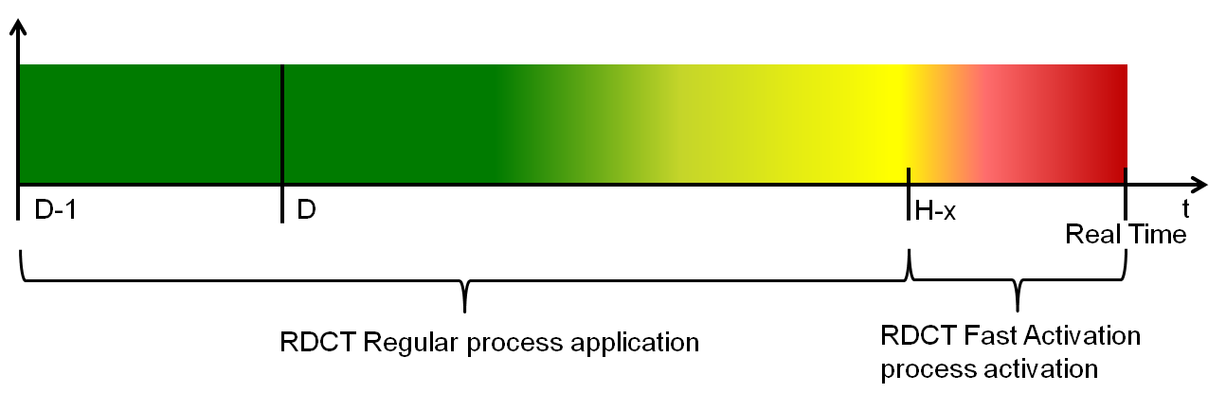

Involved parties and roles
The framework of the methodology for RDCT (see paragraph 5) relies on two main activities:
- Coordinated security monitoring of the ACI for RDCT application: this step includes the ACI security definition, monitoring and the selection of coordinated non-costly remedial actions.
- RDCT measures calculation and selection: this step is triggered once the need of RDCT is identified and it includes the selection of the RDCT measures and the calculation of their total cost.
The parties involved in the processes are TSOs and RSCs and their roles are specified in the next paragraphs.

Coordinated security monitoring of the ACI for RDCT application
For RDCT purposes one or more RSCs monitor the security of the ACI in the operational planning phase. When they detect a security violation in the ACI, they inform TSOs about the constraints and propose coordinated non-costly RAs within the available ones. For security monitoring and coordination of RAs, RSCs could take advantage from the experience gained and the tools developed for the Capacity Calculation processes (e.g. D2CC, IDCC). TSOs can validate or adjust the proposals of RSCs and have the right to block the process at this stage, with an explanation, if they deem it as not necessary (e.g. the violation of the element of the ACI is not considered as critical because of bad modelling of the system, there are additional available RAs not considered). In case the RDCT procedure triggering is confirmed by TSOs and RDCT measures need to be activated, the resources, their duration and quantities are calculated according by the tool mentioned at paragraph 7.2 7.2 (RDCT measures calculation and selection).
In case of any relevant event for the ACI (e.g. unplanned outage, line back in service before scheduled), the responsible TSO has to promptly inform the RSCs and the other TSOs in order to update the models used for RDCT process.

RDCT measures calculation and selection
In order to guarantee the maximum transparency and consistency for RDCT activation, the calculation of the needed resources will be performed with a common tool which will be jointly specified and developed by the TSOs and RSCs involved. Depending on what will be considered as feasible and economic during the specification phase, this tool could be automatic or executed manually. In the latter case the tool will be run by TSOs and/or RSCs on a rotating basis.
TSOs have the possibility to validate or adjust the proposed quantities (with an explanation).
In case the Fast Activation process for sudden critical situation is applied (see paragraph 5.2), the calculation could be performed using internal tools of TSOs, without necessarily using the common tool.

Dataset and tools

Grid models
Coordinated security monitoring of the ACI will be performed using the latest available Common Grid Models (CGMs) depending on the time of the application (e.g. DACF for day ahead, IDCF for intraday, Snapshots for real time). The data used will be the merged CGM produced by the ENTSOE European Merging Function.

Dataset for ACI definition
The input data necessary to detect the ACI will be provided via ad hoc files. The required data are:
- The lists of critical elements defined as combinations of tripping elements and elements to be monitored.
- Data for filtering the above mentioned lists according to predefined factors.
RDCT resources
The RDCT resources will be declared by each TSO using the latest available information
CT resources could be defined via a list of units whose contribution to the total shift is proportional to a predefined parameter (e.g. actual active power, reserve margin). In any case, the units selected for CT are not binding.

Non-costly remedial actions
Non-costly remedial actions are usually grid topology modifications (e.g. opening of lines or busbar couplers) and changing of PSTs taps. These remedial actions will be communicated via an ad hoc file. When the availability of a RA changes, the pertaining TSO has to communicate it as soon as possible.
Formats and contents of these files will be defined and detailed during the implementation phase.

Common platform
All data will be provided and archived on a common platform which can be used also for ex-post analysis, reporting and cost sharing purposes.

Common tool
As stated at paragraph 7.2, a common tool will be developed in order to guarantee the maximum transparency and consistency for RDCT activation.

Connection between RDCT and Capacity Calculation processes
RDCT procedures and Capacity Calculation (CC) processes have to be harmonized in order to avoid contradictory results endangering the security and efficiency of the interconnected system In this light, following links between consequential process should be enforced:
- Low results of CC could be early warnings for RDCT.
- The results of RDCT processes have to be made available for the following IDCC process. As an example, if for a future hour CT has to be activated this info could be taken into account during the CC processes..

Transparency
The involved parties commit to guarantee the transparency of the results of RDCT processes. The criteria for input data definition will be shared and a common tool will be used to calculate the costs and for the resources commitment.
Transparency of input data will be realized by:
- Using CGMs as datasets (transparency guarantee at ENTSOE level);
- Using shared and agreed criteria for ACI definition;
- Providing inputs in advance on a common platform.
Each TSO must also share the criteria it will use to define the prices of its resources. These prices have to be based on the actual market prices and/or have to reflect the effective costs incurred by the TSO (CACM c.3 a.35).

Implementation roadmap
The entry into forceof this RD and CT Methodology is subject to:
- Regulatory approval of this RD and CT Methodology in accordance with Article 9 of the CACM Regulation;
- Regulatory approval of Redispatching and Countertrading Cost Sharing Methodology required by Article 74 of the CACM Regulation in accordance with Article 9 of the CACM Regulation;
- Implementation of the capacity calculation methodology;
- Development and implementation of the systems required to support the RD and CT Methodology.

The TSOs of SEE CCR Region shall implement the proposed coordinated Redispatching and Countertrading Methodology not later than 12 months after the conditions specified in paragraphs a-c are fulfilled.

Annex 1 Redispatching and Countertrading measures summary table

 | Shift TSO A | Shift TSO B | Location dependence | Modification of schedule
Countertrading | Increasing/decreasing | Decreasing/increasing by the same volume | Independent method  (economical merit order) | YES
Internal Redispatching | Increasing and decreasing by the same volume | --- | Geographical dependent method  (sensitivity factor) | NO transaction between control areas
External Redispatching | --- | Increasing and decreasing by the same volume | Geographical dependent method  (sensitivity factor) | NO transaction between control areas
Cross Border Redispatching | Increasing/decreasing | Decreasing/increasing by the same volume | Geographical dependent method  (sensitivity factor) | YES

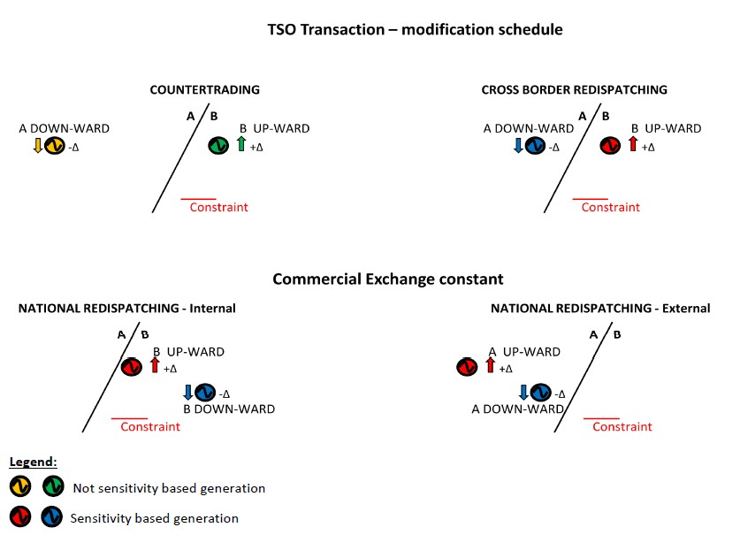

Picture 1: Redispatching and Countertrading examples

Full Activation Time = time needed between the reception of the order by the power plant and the “target power value” to be reached.
A detailed definition of this optimization procedure will be part of an implementation project.
The exact number of process runs for a day and the size of the time window to be monitored will be decided during the implementation phase in line with what is considered as feasible and reasonable.
This security monitoring is only intended for RDCT purposes and doesn’t replace the usual security monitoring on the whole TSO grids which is part of TSOs activities and required by OH Handbook and guideline on System Operation.
Except in sudden critical situations (see paragraph 6).

