Explanatory Document to all TSOs’ proposal for a methodology for the TSO-TSO settlement rules for the intended exchange of energy in accordance with ‎Article 50(1) of Commission Regulation (EU) 2017/2195 of 23 November 2017 establishing a guideline on electricity balancing

18 December 2018

Table of Contents

List of Figures 3
List of Tables 3
Definitions and Abbreviations 4
1 Introduction 7
2 EBGL Requirements for TSO-TSO Settlement rules 8
3 General Principles 9
4 Settlement Methodology for RR and mFRR with Scheduled Activation 11
4.1 Volume and Price Determination 11
4.2 Activations for system constraints purposes 11
5 Settlement Methodology for mFRR with Direct Activation 17
6 Settlement Methodology for aFRR 18
6.1 Volume and Price Determination 18
6.2 Settlement of netted volumes of aFRR demand 20
6.2.1 Definition of netted volumes of the aFRR demand 20
6.2.2 Determination of settlement prices for netted aFRR demand 20
7 Imbalance Netting 22
7.1 Examples of Determination of Value of avoided aFRR Activation 22
7.1.1 Value of avoided aFRR for a IN member that uses pay as bid 22
7.1.2 Value of avoided aFRR for a IN member that uses marginal pricing aFRR scheme 24
7.1.3 Value of avoided aFRR price for a TSO participating in aFRR cooperations 25
7.1.4 Value of avoided aFRR in case of administrative and day ahead price 25
7.2 Determination of IN settlement price 25
8 Settlement of the Balancing Congestion Income 29

List of Figures
Figure 1 The TSO-TSO settlement is done by product. 9
Figure 2: Illustration of the settlement volume 11
Figure 3: Example Scenario 12
Figure 4: Result for unconstrained run 13
Figure 5: TSO-TSO settlement result for unconstrained 14
Figure 6: Results for the constrained run 14
Figure 7: TSO-TSO settlement result for constraint run 16
Figure 12: Example for DA volume distribution 17
Figure 13: TSO-TSO settlement Volume based on AOF result 19
Figure 14: TSO-TSO settlement based on simulated and effective aFRR activation 19
Figure 11: Determination of the settlement price in case of perfect netting for aFRR netted volumes 21
Figure 16: Example of pay-as-bid pricing: upward Value of Avoided aFRR activation 23
Figure 1716: Example of pay-as-bid pricing: downward Value of Avoided aFRR activation 23
Figure 14: Example of marginal pricing: upward Value of Avoided aFRR activation 24
Figure 19: Example of marginal pricing: downward Value of Avoided aFRR activation 24

List of Tables
Table 1: Payment directions 10
Table 2: BSP bids 12
Table 3: BSP offers and the selected quantities for the UC run 13
Table 4: BSP offers and the selected quantities for the constrained run 14
Table 5: Bid volumes and price uplifts due to the constrained run 15
Table 6: Balancing costs of a TSO delivering balancing energy for system constraints 16
Table 7: Netting opposed aFRR demands 20
Table 7: variables and sign conventions for the following calculations 26
Table 8: Full Example for the adjusted settlement 28

Definitions and Abbreviations
- Definitions

‘aFRR balancing border’ means a set of physical transmission lines linking adjacent LFC areas of participating TSOs. The optimisation algorithm calculates the automatic frequency restoration power interchange for each aFRR balancing border. For the purposes of the optimisation, each aFRR balancing border has a mathematically defined negative and positive direction for the automatic frequency restoration power exchange.
‘aFRR-Platform’ means European platform for the exchange of balancing energy from frequency restoration reserves with automatic activation
‘balancing border’ means an RR, mFRR or aFRR balancing border
‘balancing congestion income’ means an income generated by the exchange of balancing energy between different uncongested areas and the resulting different CBMPs
‘balancing energy pricing period’ (hereafter referred to as “BEPP”) means a time interval for which cross-border marginal prices (hereafter referred to as “CBMP”) are calculated
‘CBMP’ means the cross-border marginal price calculated in accordance with the pricing proposal
‘cross-border capacity limits’ means the limits determined in accordance with the implementation frameworks for the exchange of balancing energy from replacement reserves, from frequency restoration reserves with manual and automatic activation as well as for the imbalance netting process
‘demand’ means a TSO demand for activation of any balancing standard product bids
‘direct activation’ means a mFRR-Platform process that can occur at any point in time to resolve large imbalances within the Time To Restore Frequency
‘divisible bids’ means a characteristic of a bid which enables its partial or fully activation
‘implementation project’ means the project which implements the RR, mFRR, aFRR and IN-Platforms, pursuant to Article 19, 20, 21 and 22 of the EBGL respectively.
‘implementation framework’ means the proposal for the European platforms pursuant to Article 19, 20, 21 and 22 of the EBGL
‘IN-Platform’ means the European platform for the imbalance netting process
'intended exchange of balancing energy’ means intended exchanges of energy as a result of the reserve replacement process, the frequency restoration process with manual activation, the frequency restoration process with automatic activation or the imbalance netting process
‘mFRR-Platform’ means European platform for the exchange of balancing energy from frequency restoration reserves with manual activation;
‘net border balancing income’ means the balancing congestion income allocated per balancing border as defined in Article 7 of the SP
‘participating TSO’ means any TSO using one of more of the European platforms to exchange RR, mFRR, aFRR and/or for the INP
‘price indeterminacy’ means that there is no unambiguous intersection point between the consumer and supply curves
‘pricing proposal’ (hereafter referred to as “PP”) means the proposal for the methodology to determine prices for balancing energy activated for different activation purposes and cross-zonal capacity in accordance with Article 30(1) and Article 29(3) of the EBGL
‘rejected bid’ means a bid which is part of the common merit order list of the AOF but is not a selected bid
‘RR-Platform’ means European platform for the exchange of balancing energy from replacement reserves
‘selected bid’ means a bid that is selected by the AOF and must be fully or partially activated
‘standard aFRR balancing energy product’ means the standard product for balancing energy from frequency restoration reserves with automatic activation
‘standard balancing energy product’ means the standard product for balancing energy from replacement reserves or frequency restoration reserves with automatic or manual activation
‘uncongested area’ means the widest area, constituted by bidding zones and/or LFC areas, where the exchange of balancing energy and the netting of demands is not restricted by the border capacity limits or other allocation constraints in accordance with the implementation frameworks for the exchange of balancing energy from replacement reserves, from frequency restoration reserves with manual and automatic activation as well as for the imbalance netting process
‘validity period’ means the period during which a balancing energy bid can be is submitted

- Abbreviations
List of abbreviations used in this document:

aFRR automatic frequency restoration reserve
AOF activation optimisation function
BSP balancing service provider
BEPP balancing energy pricing period
BRP balance responsible party
CMOL common merit order list
CZC cross-zonal capacity
DA direct activation
EBGL guideline on electricity balancing
FRCE frequency restoration control error
ISP imbalance settlement period
LFC load frequency control
MARI Manually Activated Reserves Initiative
mFRR manual frequency restoration reserve
MOL merit order list
MCP market clearing price
MW megawatt
MWh megawatt hour
NRA national regulatory authority
PICASSO Platform for the International Coordination of Automated Frequency Restoration and Stable System Operation
PP pricing proposal
QH quarter hour
SA scheduled activation
SP settlement proposal
RR replacement reserves
SOGL guideline on electricity transmission system operation
TERRE Trans European Replacement Reserves Exchange
TSO transmission system operator
TTRF time to restore frequency
CBMP cross-border marginal pricing
- Introduction
This explanatory document gives background information and rationale for the all TSOs’ proposal regarding the development of a proposal for common settlement rules applicable to all intended exchanges of energy as a result of the reserve replacement process, frequency restoration process with manual and automatic activation and the imbalance netting in accordance with to Article 50(1) of Commission Regulation (EU) 2017/2195 of 23 November 2017 establishing a guideline on electricity balancing (hereafter referred to as “SP” or “the proposal”).
The proposal and the explanatory document consider and include results previously developed by the implementation projects MARI, PICASSO, TERRE and IGCC, with respect to the settlement of exchanges of balancing energy. These include inputs provided by stakeholders during previous workshops and other established events (e.g. electricity balancing stakeholder group meetings).
The proposal has to be considered in the context of the implementation frameworks for the European platforms for the exchange of balancing energy from replacement reserves (RR), frequency restoration reserves with manual (mFRR) and automatic activation (aFRR) as well as imbalance netting (IN). Moreover, the proposal has to be considered in the context of the proposal for pricing of balancing energy and cross-zonal capacity in accordance with Article 30(1) and Article 30(3) of the EBGL.
The proposal is structured as follows:
- Chapter 2 summarizes the requirements of the relevant EBGL articles and provides an interpretation where needed.
- Chapter 3 introduces the general principles of the settlement methodology which is based on the cross-border marginal pricing (CBMP) with differentiation between products and activation types and activation purposes.
- Chapter 4 deals with the settlement methodology for scheduled mFRR and RR balancing energy bids including an explanation of price indeterminacy and pricing of system constraints with Scheduled Activation.
- Chapter 5 explains the pricing of settlement methodology for mFRR with direct activation.
- Chapter 6 provides the background on the pricing of balancing energy from aFRR. Due to the fact that aFRR is a closed-loop process where the calculation of the aFRR request by the TSOs does not only depend on imbalances but also on actual aFRR delivery by the balancing service providers (BSPs), the settlement methodology for aFRR requires a fundamental understanding of the underlying technical process and signals. The respective background information is summarized in Chapter Error! Reference source not found.. X
- Chapter Error! Reference source not found. tackles the remaining aspects of the pricing methodology, such as pricing of the specific products (Chapter Error! Reference source not found.) and pricing of cross-zonal capacity (Chapter Error! Reference source not found.) for the imbalance netting settlement process. Moreover, Chapter Error! Reference source not found. provides a short explanation regarding on the determination of the value of avoided aFRR activation and the determination of the central dispatching models settlement price.
Together with the all TSOs' proposal for the implementation frameworks, the SP will lead to a new European market for RR, mFRR and aFRR. This will increase the efficiency of the balancing energy markets and competition but also lead to many changes for stakeholders, both from harmonisation efforts and as a result of the integration of the markets.

- EBGL Requirements for TSO-TSO Settlement rules
Article 50 of the Commission Regulation (EU) 2017/2195 of 23 November 2017 establishing a guideline on electricity balancing (hereafter referred to as EBGL) requires all TSOs to develop a proposal for common settlement rules applicable to all intended exchanges of energy as a result of the reserve replacement process, frequency restoration process with manual and automatic activation and the imbalance netting. This section provides a summary of the core EBGL requirements for the SP.
Article 50(1) of EBGL is the legal basis for the proposal:
“By one year after the entry into force of this Regulation, all TSOs shall develop a proposal for common settlement rules applicable to all intended exchanges of energy as a result of one or more of the following processes pursuant to Articles 146, 147 and 148 of Regulation (EU) 2017/1485, for each of the following.
(a) the reserve replacement process;
(b) the frequency restoration process with manual activation;
(c) the frequency restoration process with automatic activation;
(d) the imbalance netting process”.
Article 50(5) of EBGL formulates the minimum scope of the proposal:
“The common settlement rules in accordance with paragraph 1 shall at least contain the provisions that the intended exchange of energy is calculated on the basis of the following criteria:
(a) over periods agreed among relevant TSOs;
(b) per direction;
(c) as the integral of the calculated power interchange over the periods pursuant to paragraph 5‎(a).”
Moreover, EBGL establishes a relationship of the settlement proposal with the pricing proposal. Article 50(6) of EBGL requires that the settlement rules related to RR, mFRR and aFRR take into account the respective balancing energy prices and the pricing of cross-zonal capacity:
“The common settlement rules of intended exchanges of energy in accordance with paragraphs 1(a), 1(b) and 1(c) shall take into account:
(a) all balancing energy prices established pursuant Article 30(1);
(b) the methodology for pricing of cross-zonal capacity used for the exchange of balancing energy pursuant Article 30(3).”
A similar requirement is formulated for the settlement rules concerning the imbalance netting process in Article 50(7) of EBGL which requires to take into account the respective cross-zonal capacity pricing methodology.
- General Principles
As the result of development of the implementation frameworks according to Articles 19, 20, 21 and 22 of the EBGL, there will be cross-border exchange of balancing and netted energy defined as intended exchange of energy by the EBGL. The SP divides the intended exchange of energy in to the intended exchange resulting from aFRR, mFRR, RR and imbalance netting platform.
In SP it is proposed, that the intended exchange volumes will be settled separately per product (with an additional differentiation between mFRR with scheduled and direct activation types). This means, that the total volume of intended exchange between TSOs is not treated as one volume to be settled, instead there is a separation, which volume is resulting from which platform and to which direction the intended exchange of energy from each platform is exchanged. Figure 1 illustrates the separation of the intended exchange to different volumes.
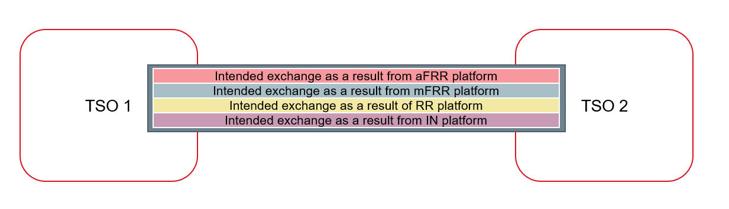
Figure 1 The TSO-TSO settlement is done by product.
In figure 1, the whole rectangle between TSOs represents the total volume of intended exchange between TSOs, but it is shown, that this total volume consists of volumes of the intended exchange from separate processes. As the settlement of volumes from each process is treated separately, volume exchanged due the aFRR platform result will be determined and settled with aFRR settlement price and volume exchanged due the mFRR platform result will be determined and settled with the mFRR settlement price and so on.
For each intended exchange volume, there will be a settlement price, again separately determined by the platform. The EBGL article 50(6) requires, that the common settlement rules of intended exchanges of energy shall take account all balancing energy prices established pursuant Article 30(1). This means that the all TSOs’ proposal on methodologies for pricing balancing energy and cross-zonal capacity used for the exchange of balancing energy or operating the imbalance netting process provides a base for the TSO-TSO settlement price.
The basic principle of the PP is to establish for each uncongested area a cross-border marginal price. The principles for setting the cross-border marginal price (CBMP) for uncongested area as well the areal construction of uncongested area is further explained in PP explanatory document section 3. This CBMP is taken as a base settlement price, that is used in TSO-TSO settlement. For each LFC-area/bidding zone, there will be CBMP and that is the price used as settlement price.
As a basic principle, the settlement amounts [€] are calculated as a product of the exchanged volume [MWh] per product and the CBMP [€/MWh] of bidding area/LFC area per product. The settlement amount however can also differ from this calculation in cases of intended exchange due the system constraint activation, the amount of congestion income and possible rents resulting from special cases with more than one price in an uncongested area or non-intuitive balancing energy flows.
The settlement of intended exchanges is done by border, i.e. between two TSOs and the payment directions are presented in the table below:
 | Settlement price positive | Settlement price negative
Exporting TSO | Receives money | Pays money
Importing TSO | Pays money | Receives money
Table 1: Payment directions

- Settlement Methodology for RR and mFRR with Scheduled Activation
  - Volume and Price Determination
In the case of RR and mFRR with scheduled activation, the total energy volume, i.e. the integral of the standard power profile, will be settled. The volumes will be settled in the form of blocks („Block Settlement“), in order to reduce the number of affected Balancing Energy Pricing Periods (BEPPs), i.e. quarter hours (QH) in case of MARI and TERRE, and simplify settlement processes.
The volume which will be settled will be equal to the requested volume for the respective BEPP, and will be settled with the CBMP of the same BEPP. In the example below, the rectangular (red area) will be settled with the CBMP of the QH_{i}.
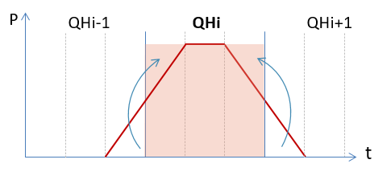
Figure 2: Illustration of the settlement volume
The settlement of netted demands follows the same approach as described for aFRR in chapter 6.
  - Activations for system constraints purposes
The TSO-TSO settlement functions of the RR-Platform and mFRR-Platform will calculate a settlement amount resulting from the activation of standard RR and mFRR balancing energy product bids for system constraints activation purpose for each BEPP. The following examples explain the calculation of the settlement amounts related to system constraints.
In the following example, the balancing demands for each TSO, the ATC values serving as cross-border capacity limits and the bids are represented in
Figure 3 and Table 2:
- For the sake of simplicity, all bids and demands have a validity period equal to the BEPP, and all demands are inelastic.
- The cross-zonal capacity between TSO2 and TSO3 is large enough so as not to influence the results,
- whereas the submitted cross-zonal capacity between TSO1 and TSO2 is 50 MW for the one direction
(1 2) and 0 MW for the opposite direction (2 1).
- TSO 2 has requested a desired flow range between 30 MW and 50 MW in the direction TSO 1 to TSO 2, i.e. bids will be selected not only for balancing but also for system constraints purpose.
Figure 3: Example Scenario
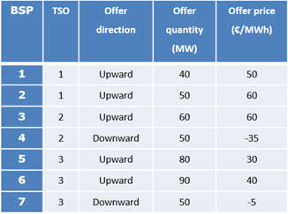
Table 2: BSP bids
As explained in the explanatory document for the pricing proposal, the AOF will execute
- an optimisation (with ATC constraints but) without taking into account the desired flow range (referred to as “unconstrained run”) and
- an optimisation (with ATC constraints and) with the desired flow range (referred to as “constrained run”)
in order compare the results between these two runs in order to distinguish prices for balancing energy (while only the constrained run is relevant for the physical activation of the bids).
Unconstrained run
In the first step, the AOF executes an unconstrained run (UC run), without considering the minimum desired flow constraint. The results of the UC run are presented in Figure 4 and the selected bids are highlighted in Table 3 below:
- As the cheapest upward bids (BSP 5 and 6) are connected to TSO 3, TSO 3 exports 50 MW to TSO 2.
- Due to the ATC constraint of 0 MW in the direction from TSO 2 to TSO 1, TSO 1 cannot import cheaper upward balancing energy and must activate the bid for 50 €/MWh (BSP 1).
- The resulting CBMPs are 50 €/MWh for TSO 1 and 40€/MWh for TSO 2 and TSO 3.
Figure 4: Result for unconstrained run
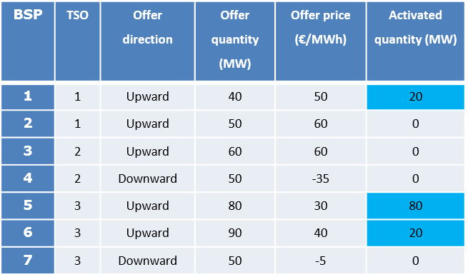
Table 3: BSP offers and the selected quantities for the UC run
The financial flows (Figure 3) between the TSOs after the UC run are thus the following (a negative payment means that the TSO receives the respective amount):
For TSO 1:
- Import/export of balancing energy: 0 MWh * 50 €/MWh = 0 €
- Congestion rent: 0 MWh * (50 €/MWh - 40 €/MWh) / 2= 0 €
For TSO 2:
- Import/export of balancing energy: 50 MWh*40 €/MWh = 2000 €
- Congestion rent: 50 MWh * (40 €/MWh - 40 €/MWh) / 2 = 0 €
For TSO 3:
- Import/export of balancing energy: -50 MWh * 40 €/MWh = -2000 €
- Congestion rent payment: 50 MWh * (40 €/MWh - 40 €/MWh) / 2= 0 €
Figure 5: TSO-TSO settlement result for unconstrained
In result, TSO 2 pays 2000 € to TSO 3 (the sum of the payments is 0 €).
Constrained run
The constrained run takes into account that TSO 2 has submitted the aforementioned desired minimum flow of 30MW and maximum flow of 50MW from TSO1 to TSO2. The AOF considers this desired flow and calculates the results presented in Figure 6 and Table 4 below:
- In order to meet the requirement for the desired flow an additional volume of upward bids in the area of TSO 1 must be selected. This volume must be at least 50 MW in order to create an exporting net position of at least 30 MW which will be transported in the direction from TSO 1 to TSO 2.
- I.e., instead of 20 MW in the UC run, the AOF selects 40 MW from the bid of BSP 1 and additional 10 MW from BSP 2 at a price of 60 €/MWh.
- As BSP 1 provides 30 MW more in comparison to the UC run, the BSPs 5 and 6 need to provide 30 MW less. As BSP 6 is more expensive than BSP 5, BSP 6 is not selected anymore and BSP 3 needs to provide 70 MW (in comparison to 100 MW in the UC run).
It has to be stressed, that in accordance with the pricing proposal the CBMP is set by the UC run, i.e.
- the CBMP for BSP 1 to be paid by TSO 1 will still be 5 0€/MWh
- and the CBMP for BSP 5 in the area of TSO 2 and TSO 3 will still be 40 €/MWh (although BSP 6 is not selected).
- Selected bids with a higher bid price than the CBMP will be remunerated with their bid price.
Figure 6: Results for the constrained run
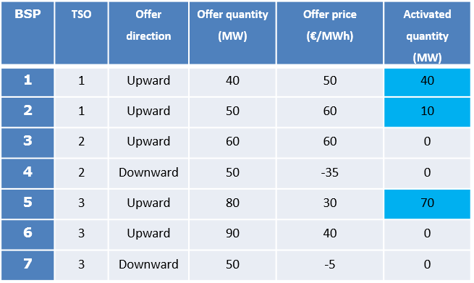
Table 4: BSP offers and the selected quantities for the constrained run
Moreover, it is worth noticing, that the consideration of the desired flow constraints does not change the total volume of selected bids as the demands must be satisfied as in the UC run.
The settlement methodology is defined in a way that the costs for TSOs with only balancing demands do not increase. I.e. neither TSO 1 nor TSO 3 will have higher balancing costs in the constrained run than in the unconstrained run. This means that all additional costs calculated as the product of
- the additional bid volumes selected for system constraints purposes with
- the difference between the respective balancing energy remuneration prices and the CBMP
must be borne by TSO 2.
The additional volumes, uplifts and additional costs for the considered scenario are summarized in Table 5. In the considered scenario, the TSO 2 has to pay 100 € due to the increased payments to the BSPs.
BSP | Volume for System Constraints | Uplift = Bid Price – CBMP | Payment by TSO 2
1 | 40 MWh – 20 MWh = 20 MWh | 50 €/MWh – 50 €/MWh = 0 €/MWh | 20 MWh* 0 €/MWh
2 | 10 MWh – 0 MWh = 10 MWh | 60 €/MWh – 50 €/MWh = 10 €/MWh | 10 MWh * 10 €/MWh
Table 5: Bid volumes and price uplifts due to the constrained run
The second component which must be considered is the reversed flow from a high price area (TSO 1) to the low price area (TSO 2 and TSO 3).
The respective rent (in this sign conventions, positive sign means payment from TSO perspective) due to non-intuitive flows is equal to the product of
- the (import) flow on the border (30 MWh) with
- the difference between the CBMPs of the exporting and importing area
In the considered example this rent is equal to 30 MWh * (50 €/MWh - 40 €/MWh) = 300 € and must also be covered by TSO 2.
The resulting financial flows (Figure 7) between the TSOs after the constrained run are thus the following (a negative payment means that the TSO receives the respective amount):
For TSO 1:
- Import/export of balancing energy: -30 MWh * 50 €/MWh = -1500 €
- System constraints: -10MWh * (60 €/MWh – 50 €/MWh) = -100€
For TSO 2:
- Import/export of balancing energy: 30 MWh * 40 €/MWh + 20 MWh * 40€/MWh = 2000 €
- System constraints
  - BSP uplifts: 10MWh * (60€/MWh - 50€/MWh) = 100€
  - Non-intuitive flows: 30MWh * (50 €/MWh-40 €/MWh) = 300 €
For TSO 3:
- Import/export of balancing energy: 20 MW * 40 €/MWh = 800 €
- System constraints: 0 MWh * 0 €/MWh (as TSO 3 neither requested activation for system constraints nor has selected bids with a higher bid price than the CBMP of this area).
Figure 7: TSO-TSO settlement result for constraint run
Table 6 shows that TSO 1 which supplies the additional 30 MW for system constraints purposes is fully compensated by TSO 2:
Payments | Without System Constraints | With System Constraints
Payment to BSP 1 | 20 MWh * 50 €/MWh = 1000 € | 40 MWh * 50 €/MW = 2000 €
Payment to BSP 2 | 0 MWh * 0 €/MWh = 0 € | 10 MWh * 60 €/MW = 600 €
TSO-TSO settlement due to balancing energy import/export | 0 MWh * 50 €/MWh = 0 € | - 30 MWh * 50 €/MWh = - 1500 €
TSO-TSO settlement due to system constraints | 0 MWh * 0 €/MWh = 0 € | - 10 MWh * 10 €/MWh = - 100 €
Total amount | 1000 € + 0 € + 0 € + 0 € | 2000 € + 600 € -1500 € - 100 €
Total amount | = 1000 € | = 1000 €
Table 6: Balancing costs of a TSO delivering balancing energy for system constraints
The same approach applies in case several TSOs have requested activation of bids for system constraint purposes. In this case the additional costs are shared proportionally to the impact of the requested activation of bids for system constraints on the balancing energy exchange on the concerned border or set of borders.
- Settlement Methodology for mFRR with Direct Activation
For mFRR with direct activation the same principles apply as specified in chapter 4, however, bids capable of being directly activated can be activated within the validity period of 15 minutes (i.e. between 7,5 minutes before and 7,5 minutes after a BEPP). Therefore, the energy volume of a direct activation to be settled between TSOs, acc. to the specified standard exchange profile, is distributed over two BEPPs (i.e. quarter hours). For the subsequent, i.e. second, BEPP (i.e. QH+1) the assigned amount equals 15 minutes multiplied by the requested power. The remaining volume (max. 14,9 multiplied by the requested power (s. example shown in Figure 8)) is attributed to the first (main) BEPP (i.e. QHi).
Hence, two blocks of volumes will be settled (and may be remunerated differently as specified in the all-TSOs pricing proposal). Prices of QHi-1 and QHi+2 are not affected.
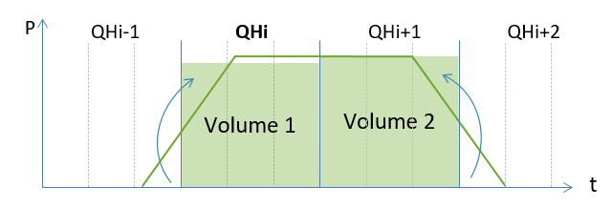
Figure 8: Example for DA volume distribution
Another difference to be highlighted at this point is that there is separate algorithm runs for positive and negative demands and the possible occurrence of positive and negative CBMPs within a single BEPP (leading to import/export of positive mFRR and import/export of negative mFRR within a single BEPP), unlike in case of the scheduled activation.
The settlement of netted demands follows the same approach as described for aFRR in chapter 6.
- Settlement Methodology for aFRR
  - Volume and Price Determination
In accordance with the general principles outlined in chapter 3, the TSO-TSO settlement for the aFRR process is based on the pricing of aFRR balancing energy in accordance with the pricing proposal and on the intended exchanged aFRR balancing energy volumes between TSOs on each aFRR balancing border (as defined in the aFRR Implementation Framework),.
This approach of determining TSO-TSO settlement volumes per aFRR balancing border based on available signals and to price them at the applicable CBMP is called the “volume-based” approach.
Due to the specificities of the aFRR process there exist, similar to pricing, different options how to determine the volumes for TSO-TSO settlement. Those options are outlined in the following chapter.
As outlined above, the proposal for pricing of aFRR balancing energy frames the proposal for the TSO-TSO settlement. After an evaluation of the potential pricing approaches, TSOs proposed to use a centralised price determination method, based on the AOF result from the aFRR Platform. In each optimisation cycle the aFRR platform generates the following output to be used for the settlement process:
- The CBMP for each LFC area (in €/MWh).
- The set(s) of LFC areas that form an uncongested area that will receive the same marginal price.
- The correction (in MW) of the aFRR demand for each LFC area reflecting total import/export of one LFC area.
- The market flow (in MW) per aFRR balancing border due to netting of aFRR demand and / or aFRR activation.
For the aFRR process, each optimisation cycle of the AOF can be seen as an independent market clearing leading to setting a CBMP for each participating LFC area. Within a harmonised ISP of 15 minutes and a minimum optimisation cycle time of one second, there will be up to 900 aFRR market clearings and resulting CBMPs as well as total import or export flows for each LFC area, depending on the duration of the aFRR optimisation cycle. Because there are multiple CBMPs available within the ISP, TSOs proposed to use the so-called “optimization-cycle balancing energy pricing period”, where for each optimization step of the AOF a CBMP is determined. This also has a direct impact on the determination of volumes for the TSO-TSO settlement for consistency matter. Since the price information is available in each optimization cycle also the volumes will need to be defined in the same frequency. However, this does not necessarily preclude a settlement between TSOs on a higher granularity.
For the volume determination for the intended exchange for the TSO-TSO settlement for aFRR, the volumes defined by the AOF of the aFRR Platform were chosen. The option is illustrated in the figure below.
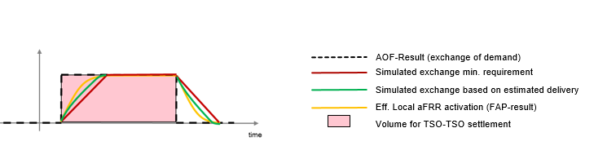
Figure 9: TSO-TSO settlement Volume based on AOF result
The AOF volume for the TSO-TSO settlement is equal to the market flows calculated by the AOF per aFRR balancing border (market flow per aFRR balancing border), which includes the volume requested for both aFRR activation and the implicit netting which is intended to flow on a specific aFRR balancing border. The sum of all market flows of one LFC area equals to the aFRR correction value (in MW) of the respective LFC area (in accordance with the control demand model).
The implicit netting includes the netting determined by the AOF of the aFRR Platform directly. The AOF volume per optimisation cycle is defined with no ramping limitations.
The AOF volume is unambiguously defined, and highly transparent, as it is a direct output from the optimisation process. As the figure shows, the AOF volumes deviate from the actual volume exchanged between LFC areas, highly dependent on the BSP profiles, which is the largest drawback of the approach. The TSO-TSO settlement based on the AOF volumes supports the desired incentive to react faster, as the discrepancy between TSO-TSO settlement and TSO-BSP settlement will be minimized by fast BSPs.
For the volume determination for the TSO-TSO settlement some alternative options were discussed. These options can be summarised in the following two different main types:
- Simulated aFRR activation on the basis of estimated BSP response
- Effective aFRR activation based on the FRCE adjustment process (FAP)
These alternative approaches for the TSO-TSO settlement volume determination are graphically illustrated in the figure below.
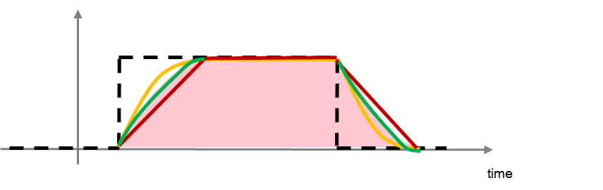 | 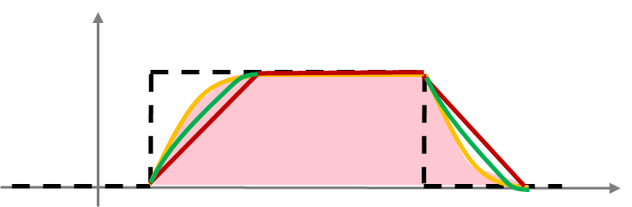
Figure 10: TSO-TSO settlement based on simulated and effective aFRR activation
Both these options give results that more accurately correspond to the actual energy delivered. However, the chosen method – AOF volume – was favoured after thorough evaluation of pros and cons. The main arguments for choosing the AOF method is transparency and simplicity. The transparency is secured because the volume determination is not based on local procedures or data, and historic data is easily accessible from the AOF of the platform. The determination of AOF volumes is virtually incontestable. The simplicity comes by a much smaller amount of data and that the data comes from the platform itself, i.e. no dependence on local data being sent back to the platform. Moreover, the chosen method ensures the consistency between the determination of the CBMP in accordance with the pricing proposal and the determination of TSO-TSO settlement volumes both in terms of frequency and source of the utilized signal.
A serious complexity that would be added if volumes were to be determined by simulation, is the development of different methods for each LFC area, and making sure that these methods don`t violate principles of a level playing field.
Also, the second alternative, to settle based on actual delivered volumes, adds complexity because it requires additional communication and indicative price signals. This alternative requires some sort of measurement of delivered volumes which is not available to all TSOs today. Moreover, TSOs agreed not to harmonize the TSO-BSP volume determination in a first stage. However, for a proper functioning of the alternative and proper incentives on BSPs, these measurements would ideally have to be harmonised if the platform implementation should be complete and equal to all participants.
  - Settlement of netted volumes of aFRR demand
    - Definition of netted volumes of the aFRR demand
Netted volume of the aFRR demand is a virtual exchange of balancing energy between cooperating LFC areas which results from netting of opposed aFRR demands. It means that an LFC area which is long supplies energy to an LFC area which is short. In that way, the netting process enables all participating TSOs to reduce their activation of aFRR balancing energy. As the implicit netting of the aFRR process results in an intended exchange of balancing energy also the exchange of netted volumes needs to be settled under the framework of the TSO-TSO settlement proposal. As outlined in chapter Error! Reference source not found. the AOF for the process within the control demand model does not differentiate between activated aFRR energy volumes and netted aFRR demand. Therefore the determination of settlement volumes due to activated aFRR and the settlement of netted aFRR demand is the same.
Table 7Error! Reference source not found. illustrates a possible netting process between four LFC areas. LFC area A is short and would activate 700 MWh positive aFRR whereas LFC areas B, C and D are long and would activate in total 600 MWh negative aFRR. For the sake of simplicity no congestions are assumed between the LFC areas. In this case TSO A imports 600 MWh while TSO B exports 100 MWh, TSO C exports 200 MWh and TSO D exports 300 MWh. The residual aFRR demand of 100 MWh after netting is covered by activating the cheapest bids of the upward CMOL. Thus due to the netting, the aFRR demand can be reduced to 100 MWh and the netting process results in avoided aFRR activation.
Indicator | TSO A | TSO B | TSO C | TSO D
aFRR demand in MWh | 700 | -100 | -200 | -300
Correction in MWh | -600 | 100 | 200 | 300
aFRR netting import in MWh | 600 | 0 | 0 | 0
aFRR netting export in MWh | 0 | 100 | 200 | 300
aFRR activation in MWh | 100 | 0 | 0 | 0
Table 7: Netting opposed aFRR demands
    - Determination of settlement prices for netted aFRR demand
In order to determine the settlement price for intended exchange of aFRR balancing energy one as to divide two cases of netted aFRR demands: Partially netted aFRR demand: netted aFRR demand in case there is subsequent activation of aFRR bids and perfect netted volume: netted aFRR demand in case there is no subsequent activation of aFRR bids.
- Partial netting
In this case, both netted aFRR demands and intended exchanges resulting from activated volumes will be settled with the respective CBMP of the uncongested area. Since each uncongested area can have a different CBMP, a balancing congestion rent has to be calculated in case of aFRR implicit netting between uncongested areas with different CBMPs. The balancing congestion rent will be shared between the involved TSOs in accordance with the proposed methodology for the distribution balancing congestion income within this proposal.
- Perfect netting
In case of perfect netting, there is only netting of opposed aFRR demands resulting in no subsequent activation of aFRR balancing energy. The resulting CBMP will be determined in accordance with the price indeterminacy rule within the PP. Therefore, the settlement price will be the average of the first ranked bid prices of the upward and downward CMOL as shown in Figure 11.
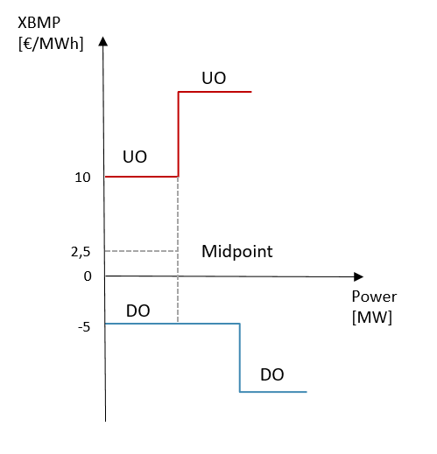
Figure 11: Determination of the settlement price in case of perfect netting for aFRR netted volumes
- Imbalance Netting
The objective of the IN settlement is to determine the IN settlement prices per IN Member per MWh for the IN energy quantities netted within IN, per IN settlement period (15 minutes).
First of all, each IN member determines its respective value of avoided upward and downward aFRR activation that should reflect the avoided costs associated to avoided aFRR energy activation. Thus, the value of avoided aFRR activation (upward and downward computed separately) will be equal to the netted upward/downward volume multiplied by the applicable (real) upward/downward aFRR price. The value of avoided aFRR Activation shall be calculated ex-post, by each IN Member, for import (upward) and export (downward) separately.
In the second step, a netting energy volume weighted average price is calculated. The resulting average price serves as input to the third step.
In the third step, the price from the second step is compared to the prices of the avoided activations. The settlement amounts are adjusted so that no TSO pays a higher price to other TSOs than the price of avoided activation.
  - Examples of Determination of Value of avoided aFRR Activation
    - Value of avoided aFRR for a IN member that uses pay as bid
The value of avoided upward/downward aFRR activation reflects the costs (upward activation) or revenues (downward activation) of the aFRR, associated to aFRR additionally activated by each participating TSO without the INP. The value of avoided aFRR prices should be determined separately for positive and negative secondary control energy per each quarter of an hour.
For the calculation of the settlement price, the average price of secondary control energy exchanged in each balancing direction during a 15-minute interval is used. Prices for activated aFRR volumes are considered as reliable proxy for the value of avoided aFRR activation. The value of avoided aFRR activation shall be calculated ex-post by each participating TSO for import and export separately.
In case positive secondary balancing is needed by this IN member, the value of avoided aFRR price corresponds with the quotient of the positive secondary control energy costs per 15 minutes and the positive secondary control energy volume per 15 minutes.
In case negative secondary control energy is needed by this IN member, the value of avoided aFRR price corresponds with the quotient of the negative secondary control energy costs or proceeds per 15 minutes and the negative secondary control energy volume per 15 minutes.
If there was no demand in a certain direction, the lowest energy price of the merit order for that direction will be used as the opportunity price.
Figure 12: Example of pay-as-bid pricing: upward Value of Avoided aFRR activation
Figure 13: Example of pay-as-bid pricing: downward Value of Avoided aFRR activation

    - Value of avoided aFRR for a IN member that uses marginal pricing aFRR scheme
In general, should both upward and downward aFRR energy directions be activated within the same 15 minutes, an upward and a downward aFRR prices will be determined, published and invoiced for both directions. These 2 marginal upward/downward prices determine the value of avoided aFRR for an IN member that uses marginal pricing aFRR scheme.
Figure 14: Example of marginal pricing: upward Value of Avoided aFRR activation

Figure 15: Example of marginal pricing: downward Value of Avoided aFRR activation

    - Value of avoided aFRR price for a TSO participating in aFRR cooperations

As long as there are TSOs participating in INP but still not participating at aFRR platform, both processes (aFRR and INP) will coexist. Examples of this situation are: a) TSOs that potentially derogate joining aFRR platform until EIF+6years (instead of EIF+4 years of go-live aFRR platform), b) TSOs that join INP platform but not aFRR platform (because for example it is not mandatory or it is not allowed to join for such TSOs).

For the calculation of the TSO-TSO settlement of the imbalance netting process performed between aFRR-Platform and IN-Platform, the value of avoided aFRR activation for TSOs participating in the aFRR-Platform shall correspond to the prices of the standard products for frequency restoration reserves with automatic activation (“standard aFRR balancing energy product”) calculated by the activation optimisation function of the aFRR-Platform.
    - Value of avoided aFRR in case of administrative and day ahead price
In case a TSO uses administrative price or day ahead price to settle aFRR balancing energy, these economic signals will be used as value of avoided aFRR activation.
  - Determination of IN settlement price
The variables used to determine IN settlement amounts are defined in the following table:
Variable | Description | Unit | Sign Convention
M | Number of IN Members | - | -
m | IN Member | - | -
t | Settlement period (15 minutes) | - | -
$$E_{Imp}\left(t,m\right)$$ | IN import of IN Member m | MWh | Always positive
$$E_{Exp}\left(t,m\right)$$ | IN export of IN Member m | MWh | Always positive
$$C_{Imp}\left(t,m\right)$$ | IN Values of Avoided aFRR Activation for import of IN Member m | €/MWh | Positive, if the IN Member m pays for activation of positive aFRR.  Negative, if the IN Member m is paid for activation of positive aFRR.
$$C_{Exp}\left(t,m\right)$$ | IN Values of Avoided aFRR Activation for export of IN Member m | €/MWh | Positive, if the IN Member m is paid for activation of negative aFRR.  Negative, if the IN Member m pays for activation of negative aFRR.
$$P_{IN}\left(t\right)$$ | IN settlement price | €/MWh | Positive or negative
$$S\left(t,m\right)$$ | Settlement amount of IN Member m | € | Positive in case of a payment by the IN Member m.  Negative in case of a claim by the IN Member m.
$$B\left(t,m\right)$$ | Rent of IN Member m | € | Positive or negative
$$B_{IGCC}\left(t,m\right)$$ | IN overall | € | Positive or negative
$$S^{'}\left(t,m\right)$$ | Adjusted settlement amount of IN Member m | € | Positive in case of a payment by the IN Member m.  Negative in case of a claim by the IN Member m.
$${P'}_{IN}$$ | Adjusted settlement price of IN Member m | €/MWh | Positive or negative
NZM | NZM = Non-Zero Members (i.e. imported energy ≠ exported energy | - | -
$$B^{'}(t,m)$$ | Adjusted rent of IN Member m | € | Positive or negative
Table 8: variables and sign conventions for the following calculations
Values of avoided aFRR activation are used as an input to determine the IN settlement price defined as the weighted average of all values of avoided aFRR activation (both upward and downward) of all IN Members with the imported and exported volumes (positive quantities) as a weighting factor.
This results in determination of unique IN settlement price of imported and exported volumes, given by the following formula (if there is no negative rent generated, this unique price is going to be used for settlement):
$$P_{IN}\left(t\right)=\frac{\sum_{m=1}^{M}{E_{Imp}\left(t,m\right)*C_{Imp}\left(t,m\right)}+\sum_{m=1}^{M}{E_{Exp}\left(t,m\right)*C_{Exp}\left(t,m\right)}}{\sum_{m=1}^{M}{E_{Imp}\left(t,m\right)}+\sum_{m=1}^{M}{E_{Exp}\left(t,m\right)}}$$

The IN settlement price is used to determine a settlement amount of each IN Member defined as the IN settlement price multiplied by the difference between amounts of imported and exported volumes of the respective IN Member:
$$S\left(t,m\right)=\left[E_{Imp}\left(t,m\right)-E_{Exp}\left(t,m\right)\right]*P_{IN}\left(t\right)$$

The settlement amount of each IN Member shall be used to determine a rent B(t,m) of each IN Member. The rent of each IN Member is defined as a difference between:
  - the import Value of avoided aFRR Activation multiplied by imported volume minus the export Value of avoided aFRR Activation multiplied by exported volume of the respective IN Member, and
  - the settlement amount of each IN Member.
Thus, rent B(t,m) is calculated according to the following formula:

$$B\left(t,m\right)=\left[E_{Imp}\left(t,m\right)*C_{Imp}\left(t,m\right)-E_{Exp}\left(t,m\right)*C_{Exp}\left(t,m\right)\right]-S\left(t,m\right)$$
$$B_{INP}\left(t\right)=\sum_{m=1}^{M}{B(t,m)}$$

The settlement procedure may result in negative rent for some IN Member(s). The reason of this potential negative rent is that INP does not consider economic information when performing netting of aFRR needs. A negative rent for a IN Member may occur in one of the following scenarios:
  - The initial IN settlement price is higher than the Value of avoided positive aFRR Activation
  - The initial IN settlement price is lower than the Value of avoided negative aFRR Activation
In case of a negative rent for some IN Members and a positive IN overall rent in the same settlement period, the settlement amounts are subject to an adjustment. Negative rents are shifted to zero. Positive rents are reduced proportionally while preserving the IN overall rent. IN Members with equal IN import and export in a given settlement period are excluded from this adjustment. The adjustment results in the following adjusted settlement prices for negative rent IN Members in the affected settlement periods:
  - In case of initial IN settlement price higher than the Value of avoided positive aFRR Activation, the settlement price for intended energy import as result of the INP for this IN Member shall be equal to its Value of avoided positive aFRR Activation
  - In case of initial IN settlement price lower than the Value of avoided negative aFRR Activation, the settlement price for intended energy export as result of the INP for this IN Member shall be equal to its Value of avoided negative aFRR Activation
Thus, the procedure to calculate the adjusted settlement amounts $S^{'}\left(t,m\right)$, in the case of negative rent occur for one or several INP members, is shown in the following formulas:

- For IN Member with negative rent and not equal import and export:
$$S^{'}\left(t,m\right)=S\left(t,m\right)+B(t,m)$$

- For IN Member with positive rent and not equal import and export:
$$S^{'}\left(t,m\right)=S\left(t,m\right)-\sum_{i∈NZM(t)}{\min\left[0,B\left(t,i\right)\right]}*\frac{B(t,m)}{\sum_{i∈NZM(t)}{\max\left(0,B\left(t,i\right)\right)}}$$

All IN imports and IN exports are settled with the final IN settlement prices of each IN Member.

$${P'}_{IGCC}\left(t,m\right)=\left\{\begin{matrix}\begin{matrix}P_{IGCC}\left(t,m\right), if m ∉NZM(t) \\ \frac{S^{'}\left(t,m\right)}{E_{Imp}\left(t,m\right)-E_{Exp}\left(t,m\right)} , if m∈NZM(t) \end{matrix} & & \begin{matrix} \\ \end{matrix}\end{matrix}\right.$$

In case of a IN negative overall rent but with both positive and negative individual IN members rent it will be applied an equivalent procedure to the one described above, netting to zero all individual positive rent and thus reducing in a pro-rata basis the individual negative rent of affected IN members.
In case of negative IN overall rent and with all negative individual IN members, no adjustment will be carried out.
in case of overall rent equal to zero, it will be necessary to shift all rents to 0 (in order to avoid the potential scenario of negative rent members flowing towards positive rent members).
The following table shows a full example for the calculation of the settlement prices, settlement amounts, rents, adjusted settlement amounts, adjusted rents and adjusted settlement prices.
Variable | Unit | Member 1 | Member 2 | Member 3 | Member 4 | Member 5
$$E_{Imp}$$ | [MWh] | 6,57 | 1,40 | 2,00 | 3,40 | 0,50
$$E_{Exp}$$ | [MWh] | 2,00 | 1,40 | 4,17 | 5,80 | 0,50
$$C_{Imp}$$ | [€/MWh] | 59,50 | 51,00 | 75,95 | 67,69 | 10,00
$$C_{Exp}$$ | [€/MWh] | 12,00 | 35,20 | 29,94 | 67,69 | 55,00
$$P_{IGCC}$$ | [€/MWh] | 52,905 | 52,905 | 52,905 | 52,905 | 52,905
$$S$$ | [€] | 241,78 | 0,00 | -114,80 | -126,97 | 0,00
$$B$$ | [€] | 125,14 | 22,12 | 141,85 | -35,48 | -22,50
$$B_{IGCC}$$ | [€] | 231,13
$$S^{'}$$ | [€] | 258,41 | 0 | -95,95 | -162,46 | 0
$${P'}_{IGCC}$$ | [€/MWh] | 56,545 | 52,905 | 44,217 | 67,692 | 52,905
$$B'$$ | [€] | 108,51 | 22,12 | 123,00 | 0,00 | -22,50
Table 9: Full Example for the adjusted settlement
Since the IN settlement price can be positive, negative or zero, IN imports and IN exports can lead to claims and debts. For this reason invoices or credit notes will be issued by the Invoicing TSO. These will include the following positions (from the perspective of the Invoicing TSO):
- IN Member exports to IN with positive or zero IN settlement price (IN Member receives payment)
- IN Member exports to IN with negative IN settlement price (IN Member pays)
- IN Member imports from IN with negative IN settlement price (IN Member receives payment)
IN Member imports from IN with positive or zero IN settlement price (IN Member pays)
- Settlement of the Balancing Congestion Income
A balancing congestion income originates in the situation where the transmission capacity available between locations is not sufficient to accommodate all economically optimal cross-border exchanges. The differences in CBMPs between the uncongested areas result in rents which must be settled between the TSOs.
The TSOs propose to apply the same methodology for sharing the balancing congestion income as proposed for the sharing of the congestion rent in the day-ahead energy market.

For the determination of CBMP in the aFRR process the interested reader is referred to the pricing proposal.

